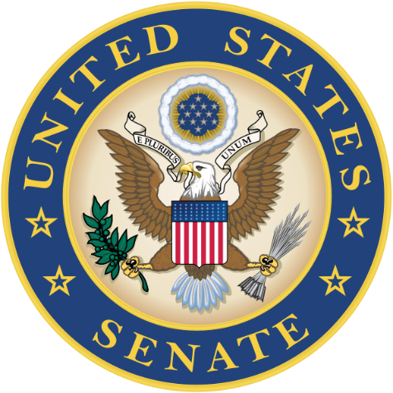
Academy
Day 2015
Interested in a service academy nomination?

U.S. Senator Ron Johnson and U.S. Senator Tammy Baldwin

along with

U.S. Representative Glenn Grothman, U.S. Representative Reid Ribble
U.S. Representative Ron Kind, U.S. Representative Sean Duffy and
U.S. Representative Mark Pocan

invite interested high school students, teachers and parents to meet with representatives from the

U.S. AIR FORCE ACADEMY
U.S. COAST GUARD ACADEMY
U.S. MERCHANT MARINE ACADEMY
U.S. MILITARY ACADEMY
U.S. NAVAL ACADEMY

Date: Saturday, Sept. 19, 2015
Time: 9:30 a.m. to 12:30 p.m.
Place: Experimental Aircraft Association Aviation Center
3000 Poberezny Road, Oshkosh

For more information, contact your guidance counselor or
Senator Johnson’s Oshkosh office: (920) 230-7250

